2009-2010 NCRA Young Authors Competition
Directions

- Distribute the Young Authors’ theme for 2009-10 to all your teachers.
- At your staff meetings go over and encourage teachers to participate in the contest. Teachers may write also as Forever Young writers.
- Decide on a due date that will give you enough time to select and type your school winners and get them to me by November 16.

- When you have collected all your school entries, get several TRCIRA members to help you select your school winners. Be sure all the guidelines for entries are followed. (title, no more than 300 words, focus on theme) I have enclosed the state rubric that was used for judging last year. All the school winners you select and send to me will be published in our county book and be honored at our celebration on May 3, 2010. (please put this date on your school calendar to let everyone know)

- Send home an entry form with each school winner to be signed by his/her parent. We must have permission from parents for printing entries. These forms must be taped to the back of the typed entry. If the student did artwork with the selection, please tape an entry form for the artwork on the back of it also.

- Forever Young writers must be members of the reading council. This is a state rule. You may send as many forever young entries as you like. There is no limit for those. Please have them complete an entry form and tape it to the back of it.
- When you type your entries, please follow the directions for sending entries that I have enclosed. When you type your entries, please save them on a CD (I have included a CD) so that I can edit and print copies for our book as well as the state entries. Send your correctly typed entries with the permission forms taped to the back and the computer cd for your school to me by November 16.

- Have someone design your school page for our county book in black ink. This is the page that divides schools in the county book. Please try to do this.

- Send your copies, CD(be sure you did it correctly), and school page to me (Pattie Jones) at WJ Gurganus or to our reading council box at Central Services.
Address: Twin Rivers Reading Council
Young Authors Program
Central Services
- Every school should have a representative to help read and choose entries to send to the state level. We will meet November 19 at Creekside Elem.

- If you have questions, my number is 229-4637 or 444-5150 or email me at Patti.Jones@craven.k12.nc.us

NCRA 2009-10 Young Authors Project
“Surfing the Waves of Literacy”

Guidelines for Entries

- All entries must be original creations.

- All entries must be typed in Microsoft WORD (not Works) format using the “Times New Roman” font and ready for publication.

- There should be an original title typed with first letter in each word capitalized, BOLD, 12 font.

- Text of story should be typed in single space, 10 font.

- Author information should follow the story, leaving 2 blank lines only, and be in the following format, 10 font:
Name
School
Grade
Local Reading Council

- Grades K-8 selections should have no more than 300 words.

- Grades 9-12 and Forever Young should have no more than 500 words total.

- Only one entry per person may be submitted.

- A completed “Young Author Entry Form”(permission form) must be taped on the back of each entry.

- Artwork may be submitted with a written entry by the same person. (only send original artwork—no copies please)

Twin Rivers Reading Council
and
North Carolina Reading Association
Invites
all teachers and students
to participate in
the 2009-2010 Young Authors’ Writing Competition

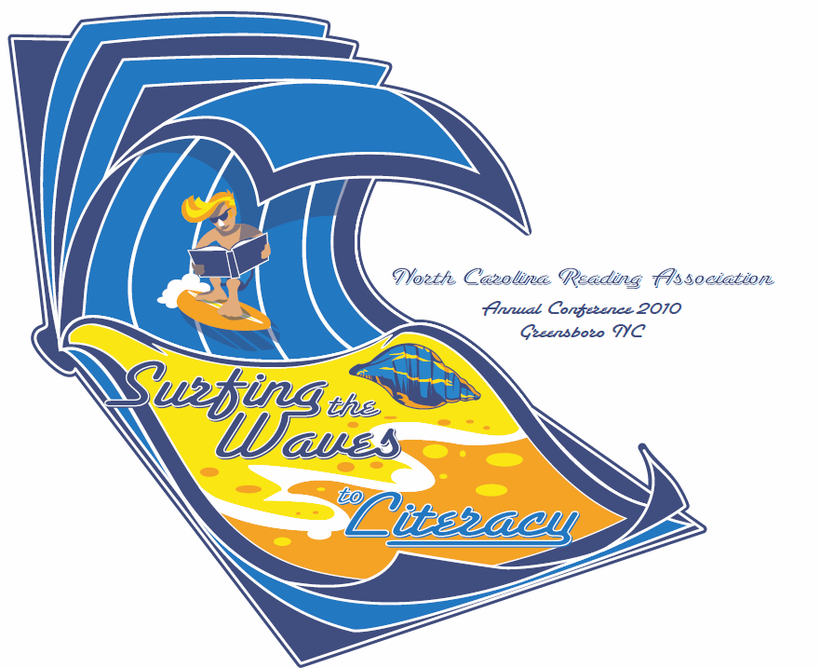

“Surfing the Waves of Literacy”

Let your imaginations flow with ideas for this year’s theme. You may write about trips to the beach, living at the coast, discoveries of things you find at the beach, things that live in the ocean, things you do or eat at the beach that are different or unusual, or favorite beach stories or books you have read. Be creative—write your story from the perspective of another individual (or animal!). Stretch your talents and create a winner!

You may write in poetry or prose (story) form. It may be fiction or non-fiction. Only one entry per person. You may do artwork with your story. Put your artwork in black ink or colored ink on a white background on 8 ½ “ by 11” paper.

For K-8 grades, there can be no more than 300 words per entry and every word is counted. For high school and Forever Young writers (adults) there can be no more than 500 words.

Share your writings with us. School winners will be published in a book you’ll be given at our celebration on May 3, 2009. You could also be a state winner and be published in a book with writers from all over North Carolina.

Plan your writings now. We need them by November 16, 2009. See your TRCIRA building rep today for more information.

